REGULATORY REFORM (FIRE SAFETY) ORDER 2005 FIRE RISK ASSESSMENT



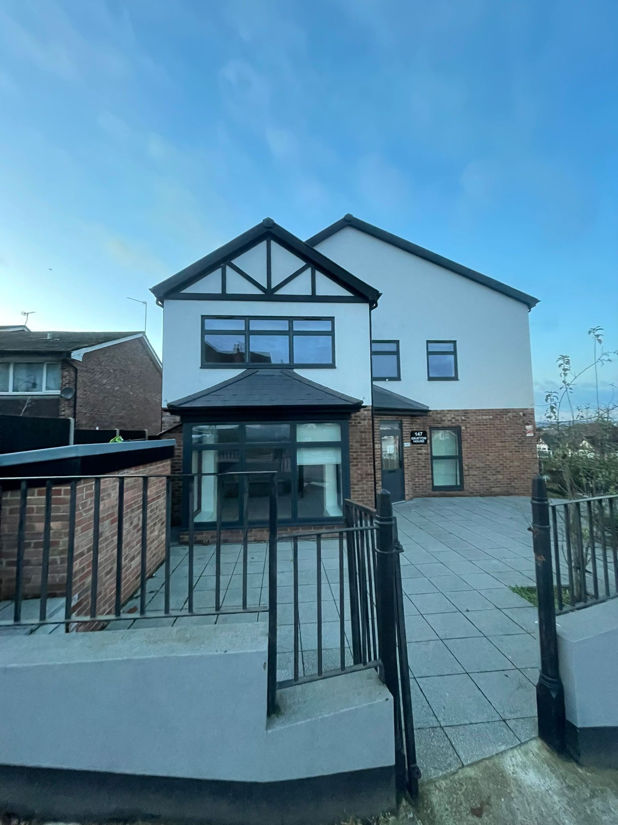
Fire Risk Assessment 147 Wembley Hill Road, Wembley, HA9 8DU

Responsible person (e.g. employer) or person | Landlord
having control of premises:
Address of premises: | 147 Wembley Hill Road, Wembley, HA9 8DU
Person(s) consulted: | Landlord
Assessor: | Mohammed Shahinul Amin
Assessors statement: | The purpose of this PAS 79-2:2020 (Annex A) Housing risk report is to provide a non-invasive assessment of the risk to life from fire in these premises, and, where appropriate, to make recommendations to ensure compliance with fire safety legislation. This report does not address the risk to property or business continuity from fire. I certify that to the best of my knowledge, the information contained in this fire risk assessment is  correct, based on information provided at the time the assessment was undertaken.
Report validated by: | N/A
Date of fire risk assessment: | 27/11/24
Date of previous fire risk assessment: | N/A
Suggested date for review: | 26/11/25
Fire Risk Assessment Review: | This fire risk assessment should be reviewed by a competent person by the date indicated above or at such  earlier time as there is reason to suspect that it is no longer valid, or there has been significant change in the matters to which it relates, or if a fire occurs.
Report compliance: | This report is intended to assist you in compliance with Article 9 of the Regulatory Reform (Fire Safety) Order  2005 which requires that a fire risk assessment be carried out.

1.00 | THE PREMISES (Clause 12)
1.01 | Number of floors at ground level and above: | 3 floors
 | Number of floors entirely below ground level: | 1 floor
 | Floors on which car parking is provided: | Ground floor
1.02 | Number of flats: | 6 flats
 | Approximate gross floor area: | 30m² Communal area.
1.03 | Brief details of construction and approximate age of building: | 147 Wembley Hill is a residential development in Wembley, Greater London. It has 6 flats and was completed in 2021.
1.04 | Occupancy: | Block of flats
2.00 | THE OCCUPANTS (Clause 12)
2.01 | Approximate maximum number of employees at any one time: | N/A
2.02 | Approximate maximum number of residents and visitors at any one time: | N/A
3.00 | OCCUPANTS ESPECIALLY AT RISK FROM FIRE (Clause 12)
3.01 | Sleeping occupants | Yes
3.02 | Occupants in remote areas and lone workers: | N/A
3.03 | Others: | N/A
3.04 | Disabled occupants (if known): | Unknown
4.00 | FIRE LOSS EXPERIENCE
4.01 | Fires in the past: | 0
4.02 | Cost of past fire losses: | N/A

5.00 | OTHER RELEVANT INFORMATION
5.01 | Detail here if required: | Grade A Fire Alarm System
6.00 | RELEVANT FIRE SAFETY LEGISLATION
6.01 | The following fire safety legislation applies to these premises: | Regulatory Reform (Fire Safety) Order 2005, The Fire Safety Act 2021, The Fire Safety Regulations (England) 2022 and Building Safety Act 2022.
6.02 | The above legislation is enforced by: | London Fire Brigade
6.03 | Other legislation that makes significant requirements for fire precautions in | The Housing Act 2004
 | these premises:
6.04 | The other legislation referred to above is enforced by: | Local Authority
6.05 | Is there an alterations notice in force? | N/A
6.06 | Relevant information and deficiencies observed: | N/A
6.07 | Other information if required: | N/A

INDEX | DETAIL | YES | NO | N/A | CONTROL MEASURES
7.00 | ELECTRONIC SOURCES OF IGNITION  (Clause 13 and Annex B)
7.01 | Are reasonable measures taken to prevent fires of electrical origin? | ✓
7.02 | More specifically:
7.02 a) | Are fixed installations periodically inspected and  tested? | ✓
7.02 b) | Is portable appliance testing carried out? | ✓
 | Observations:
8.00 | SMOKING  (Clause 13 and Annex B)
8.01 | Are reasonable measures taken to prevent fires as  a result of smoking? | ✓
8.02 | More specifically:
8.02 a) | Is smoking prohibited in appropriate areas? | ✓
8.02 b) | Are there suitable arrangements for those who  wish to smoke? | ✓
8.02 c) | Did the smoking policy appear to be observed at  the time of inspection? | ✓
8.02 d) | Are "No smoking" signs provided in the common  areas? | ✓
 | Observations:
9.00 | ARSON  (Clause 13 and Annex B)
9.01 | Does basic security against arson by outsiders  appear reasonable? | ✓

INDEX | DETAIL | YES | NO | N/A | CONTROL MEASURES
9.02 | Is there an absence of unnecessary fire load in close proximity to the premises or available for  ignition by outsiders? | ✓
 | Observations:
10.00 | PORTABLE HEATERS, HEATING AND VENTILATION SYSTEMS  (Clause 13 and Annex B)
10.01 | Is there satisfactory control over the use of portable  heaters? |  |  | ✓
10.02 | Are fixed heating and ventilation installations  subject to regular maintenance? |  |  | ✓
 | Observations:
11.00 | COOKING  (Clause 13 and Annex B)
11.01 | Are reasonable measures taken to prevent fires as a result of cooking? |  |  | ✓
 | Observations:
12.00 | LIGHTNING  (Clause 13 and Annex B)
12.01 | Does the building have a lightning protection  system? | ✓
 | Observations:
13.00 | HOUSEKEEPING  (Clause 13 and Annex B)
13.01 | Is the overall standard of housekeeping adequate? | ✓
13.02 | More specifically:
13.02 a) | Do combustible materials appear to be separated  from ignition sources? | ✓
13.02 b) | Is unnecessary accumulation or inappropriate storage of combustible materials or waste | ✓
13.02 c) | Are gas and electricity intake/meter cupboards adequately secured and kept clear of combustible  materials? | ✓

INDEX | DETAIL | YES | NO | N/A | CONTROL MEASURES
 | Observations:
14.00 | HAZARDS INTRODUCED BY OUTSIDE CONTRACTORS AND BUILDING WORKS  (Clause 13 and Annex B)
14.01 | Is there satisfactory control over works carried out  in the building? | ✓
 | Observations:
15.00 | DANGEROUS SUBSTANCES  (Clause 13)
15.01 | Are the general fire precautions adequate to address the hazards associates with dangerous  substances used or stored within the premises? |  |  | ✓
 | Observations:
16.00 | OTHER SIGNIFICANT FIRE HAZARDS THAT  WARRANT CONSIDERATION
16.01 | Hazards: |  |  | ✓
 | Observations:

INDEX | DETAIL | YES | NO | N/A | CONTROL MEASURES
17.00 | MEANS OF ESCAPE  (Clause 15c) and Annex C)
17.01 | Is the design and maintenance of the means of  escape considered adequate? | ✓
17.02 | More Specifically:
17.02 a) | Are there reasonable distances of travel:
17.02 a1) | Where there is escape in a single direction? | ✓
17.02 a2) | Where there are alternative means of escape? | ✓
17.02 b) | Is there adequate provision of exits? | ✓
17.02 c) | Do fire exits open in the direction of escape,  where necessary? | ✓
17.02 d) | Are the arrangements provided for securing exits  satisfactory? | ✓
17.02 e) | Is the fire-resisting construction (including any glazing) protecting escape routes and staircases of a suitable standard and maintained in sound  condition? | ✓
17.02 f) | Is the fire resistance of doors to staircases and the common areas considered adequate, and are the doors maintained in sound condition? | ✓
17.02 g) | Are suitable self closing devices fitted to fire doors in the common areas? | ✓
17.02 h) | Is the fire resistance of doors to meter cupboards/store rooms/plant rooms in common areas considered adequate, and are they adequately secured and/or fitted with suitable self-  closing devices? | ✓

INDEX | DETAIL | YES | NO | N/A | CONTROL MEASURES
17.02 i) | Is the fire resistance of flat entrance doors considered adequate, and are the doors maintained in sound condition? | ✓
17.02 j) | Are suitable self closing devices fitted to flat entrance fire doors and, where fitted, maintained in good working order? | ✓
17.02 k) | Are there adequate smoke control provisions to protect the common escape routes, where  necessary? | ✓
17.02 l) | Are all escape routes clear of obstructions? | ✓
17.02 m) | Are all fire exits easily and immediately openable? | ✓
17.02 n) | Are there reasonable arrangements for means of escape for disabled people? |  |  | ✓
 | Observations:
18.00 | MEASURES TO LIMIT FIRE SPREAD AND DEVELOPMENT  (Clause 15g)
18.01 | Is it considered that there is/are:
18.01 a) | Adequate levels of compartmentation between floors and between flats and the common escape  routes? | ✓
18.01 b) | Reasonable limitation of linings that may promote  fire spread? | ✓
18.01 c) | As far as can be reasonably be ascertained, reasonable fire separation within any roof space? | ✓
18.01 d) | Adequately fire protected service risers and/or  ducts in common areas, that will restrict the spread of fire and smoke? | ✓

INDEX | DETAIL | YES | NO | N/A | CONTROL MEASURES
18.02 | As far as can be reasonably be ascertained, are fire dampers provided necessary to protect critical means of escape against passage of fire, smoke and products of combustion in the early stages of  a fire? | ✓
 | Observations:
19.00 | EMERGENCY ESCAPE LIGHTING  (Clause 15e)
19.01 | Has a reasonable standard of emergency escape  lighting system been provided? | ✓
 | Observations:
20.00 | FIRE SAFETY SIGNS AND NOTICES  (Clause 15d)
20.01 | Is there a reasonable standard of fire safety signs  and notices? | ✓
 | Observations:
21.00 | MEANS OF GIVING WARNING IN CASE OF FIRE  (Clause 15b)
21.01 | Is a reasonable fire detection and fire alarm system provided in common areas, where necessary? | ✓
21.02 | If there is a communal fire detection and fire  alarm system, does it extend into the dwellings? | ✓
21.03 | Where appropriate, has a fire alarm zone plan  been provided? | ✓
21.04 | Where appropriate, are there adequate  arrangements for silencing and resetting an alarm condition? | ✓
 | Observations:
22.00 | MANUAL FIRE EXTINGUISHING APPLIANCES  (Clause 15f)

INDEX | DETAIL | YES | NO | N/A | CONTROL MEASURES
22.01 | Is there reasonable provision of manual fire extinguishing appliances? |  | ✓ |  | Are extinguishers required in common areas?  Replace the non standard fire extinguishers with BS/LPC approved extinguishers in the following locations.
22.02 | Are all fire extinguishing appliances readily  accessible? |  | ✓ |  | Remove obstructions in the following places:
 | Observations:
23.00 | RELEVANT AUTOMATIC FIRE EXTINGUISHING SYSTEMS  (Clause 15h)
23.01 | Type of fixed system(s):
23.01 a) | Sprinkler system? |  |  | ✓
23.01 b) | Misting system? |  |  | ✓
 | Observations: (List fixed systems)
24.00 | OTHER RELEVANT FIXED SYSTEMS AND EQUIPMENT  (Clause 15i)
24.01 | Type of other fixed system(s) installed: |  |  | ✓
24.02 | Are there appropriately sited facilities for electrical isolation of any photovoltaic (PV) cells, with appropriate signage, to assist the fire and rescue  service? | ✓
 | Observations:

INDEX | DETAIL | YES | NO | N/A | CONTROL MEASURES
25.00 | PROCEDURES AND ARRANGEMENTS  (Clause 16)
25.01 | Safety assistance: | ✓
25.02 | Fire safety at the premises is managed by: | ✓
25.03 | Is there a suitable record of the fire safety  arrangements? | ✓
25.04 | Evacuation strategy: | ✓
25.05 | Are procedures in the event of a fire appropriate  and properly documented, where appropriate? | ✓
25.06 | Are routine in-house inspections of fire precautions undertaken (e.g. in the course of health and safety  inspections? | ✓
 | Observations:
26.00 | TRAINING AND DRILLS  (Clause 16h)
26.01 | Are all staff given adequate fire safety instruction  and training on induction? |  |  | ✓
26.02 | When the employees of another employer work in the premises, is appropriate information on the fire  risks and fire safety measures provided? |  |  | ✓
 | Observations:
27.00 | TESTING AND MAINTENANCE  (Clause 16j)
27.01 | Is there adequate maintenance of the premises? | ✓
27.02 | Is weekly testing and periodic servicing of fire  detection and alarm system undertaken? |  | ✓ |  | Ensure that weekly fire alarm test and periodic servicing are carried out and  recorded by competent persons.
27.03 | Is monthly and annual testing routines for  emergency lighting? |  | ✓ |  | Ensure that monthly, six monthly and annual emergency lighting carried out and  recorded by competent persons.
27.04 | Is annual maintenance of fire extinguishing  appliances undertaken? |  | ✓ |  | Ensure that monthly checks, and annual maintenance of portable fire fighting  appliances are carried out and recorded by competent persons.
27.05 | Are six-monthly inspection and annual testing of  rising mains undertaken? |  | ✓ |  | Arrange six-monthly inspection and annual pressure testing of dry riser.

INDEX | DETAIL | YES | NO | N/A | CONTROL MEASURES
27.06 | Are weekly and monthly testing, six monthly inspection and annual testing of fire-fighting lift(s) provided for the use by firefighters or evacuation of  disabled people (evacuation lifts)? |  | ✓ |  | Arrange weekly and monthly testing, six monthly inspection and annual testing of fire-fighting or evacuation lifts.
27.07 | Other relevant inspections or tests? |  |  | ✓
 | Observations:
28.00 | RECORDS  (Clause 16k)
28.01 | Are there appropriate records of:
28.01 a) | Fire alarm tests (where relevant)? |  | ✓ |  | Provide and maintain a register of records for fire alarm tests.
28.01 b) | Emergency escape lighting tests? |  | ✓ |  | Provide and maintain a register of records for emergency lighting tests.
28.01 c) | Maintenance and testing of other fire protection  equipment? |  | ✓ |  | Provide and maintain a register of records for fixed fire system tests.
29.09 | Is the fire emergency plan available to the  enforcing authority? |  | ✓ |  | Ensure that fire emergency plan is readily available for enforcing authority  inspection.
29.10 | Are Personal Emergency Evacuation Plans (PEEPS) required and in place? |  | ✓ |  | Ensure that Personal Emergency Evacuation Plans are compiled in accordance DCLG guidance and is readily available for enforcing authority inspection.
 | Observations:
29.00 | PREMISES INFORMATION BOX  (Clause 15c)
29.01 | Is there a suitably located premises information box  for the fire and rescue service? |  | ✓ |  | Provide premises information box with details to assist the fire and rescue service.
29.02 | Are there arrangements to keep the premises  information box up to date? |  | ✓ |  | Regularly check and update the premises information box.
30.00 | ENGAGEMENT WITH RESIDENTS  (Clause 16l)
30.01 | Has information on fire procedures been  disseminated to residents? |  | ✓ |  | Provide a clear fire action document for all residents.
30.02 | Is fire safety information disseminated to  residents? |  | ✓ |  | Provide a clear fire safety information for all residents.

Risk Value Matrix
FIRE RISK ASSESSMENT RISK REGISTER

Likelihood | Value | Severity of Outcome(s)
Negligible | 1 | Negligible
Low | 2 | Minor injury to occupants, first aid required
Moderate | 3 | Moderate Injury to occupants, medical attention required.
High | 4 | Occupants required hospitalisation.
Extreme | 5 | Major loss of life.

Severity
Likelihood

1 | 2 | 3 | 4 | 5
2 | 4 | 6 | 8 | 10
3 | 6 | 9 | 12 | 15
4 | 8 | 12 | 16 | 20
5 | 10 | 15 | 20 | 25

Likelihood Severity
Risk Rating Score:
4

2
2

Risk Rating | Action PAS 79-1:2020
Trivial | Record findings and review in 12 months
Tolerable | No major additional controls required. However, There might be a need for improvements that involve minor or limited costs.
Moderate | It is essential that efforts are made to reduce the risk. Risk reduction measures should be implemented within a defined time period.
 | Where moderate risk is associated with consequences that constitute extreme harm, further assessment might be required to establish more precisely the likelihood of harm as a basis for determining the priority for improved control measures.
Substantial | Considerable resources might have to be allocated to reduce the risk. If the building is unoccupied, it should not be occupied until the risk has been reduced. If the building is occupied, urgent action should be taken.
Intolerable | Building (or relevant area) should not be occupied until the risk is reduced.

Fire Risk Assessment Review
Assessments should be kept under constant review, and in any case reviewed whenever circumstance change which affect the validity of the current assessment. Whilst there is no maximum period between assessments, it is recommended that the review period should not exceed 12 months.

QUESTION | SIGNIFICANT HAZARDS | RESPONSIBLE  PERSON | TARGET DATE | DATE COMPLETED &  INITIAL
22.00 | MANUAL FIRE EXTINGUISHING APPLIANCES  (Clause 15f)
22.01 | Are extinguishers required in common areas?  Replace the non standard fire extinguishers with BS/LPC approved extinguishers in the following locations. | Landlord | 4 Weeks
23.00 | RELEVANT AUTOMATIC FIRE EXTINGUISHING SYSTEMS  (Clause 15h)
24.00 | OTHER RELEVANT FIXED SYSTEMS AND EQUIPMENT  (Clause 15i)
25.00 | PROCEDURES AND ARRANGEMENTS  (Clause 16)
25.03 | Review fire emergency plan to detail required fire safety arrangements. | Landlord | Continuously
25.06 | Ensure that all required routine fire inspections are carried out. | Landlord | Continuously
26.00 | TRAINING AND DRILLS  (Clause 16h)
27.00 | TESTING AND MAINTENANCE  (Clause 16j)
27.01 | Ensure that checks, inspections and maintenance are carried out at appropriate  intervals. | Landlord | Continuously
27.02 | Ensure that weekly fire alarm test and periodic servicing are carried out and  recorded by competent persons. | Landlord | Continuously

QUESTION | SIGNIFICANT HAZARDS | RESPONSIBLE  PERSON | TARGET DATE | DATE COMPLETED &  INITIAL
27.03 | Ensure that monthly, six monthly and annual emergency lighting carried out and  recorded by competent persons. | Landlord | Continuously
27.04 | Ensure that monthly checks, and annual maintenance of portable fire fighting  appliances are carried out and recorded by competent persons. | Landlord | Continuously
28.00 | RECORDS  (Clause 16k)
28.01 a) | Provide and maintain a register of records for fire alarm tests. | Landlord | Continuously
28.01 b) | Provide and maintain a register of records for emergency lighting tests.
28.01 c) | Provide and maintain a register of records for fixed fire system tests. | Landlord | Continuously
29.00 | PREMISES INFORMATION BOX  (Clause 15c)
30.00 | ENGAGEMENT WITH RESIDENTS  (Clause 16l)
30.01 | Provide a clear fire action document for all residents. | Landlord | Continuously
30.02 | Provide a clear fire safety information for all residents. | Landlord | Continuously

PHOTOGRAPHS
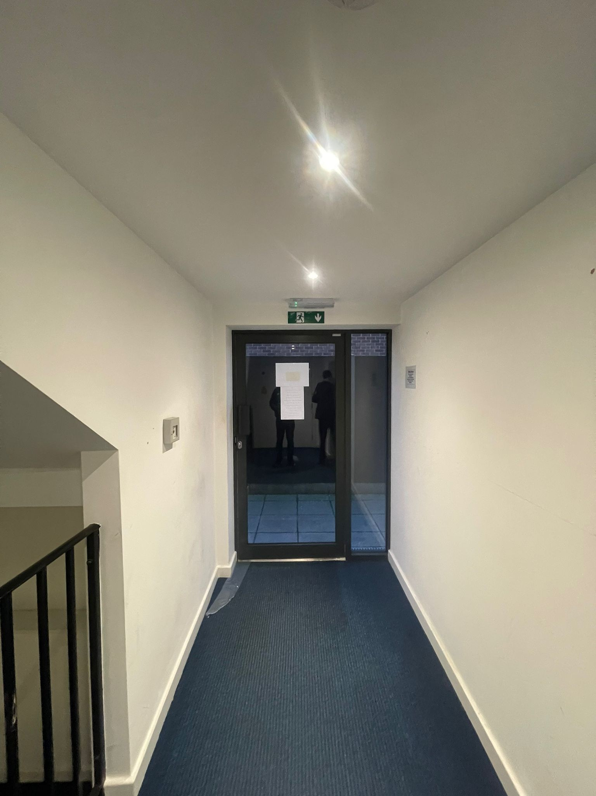
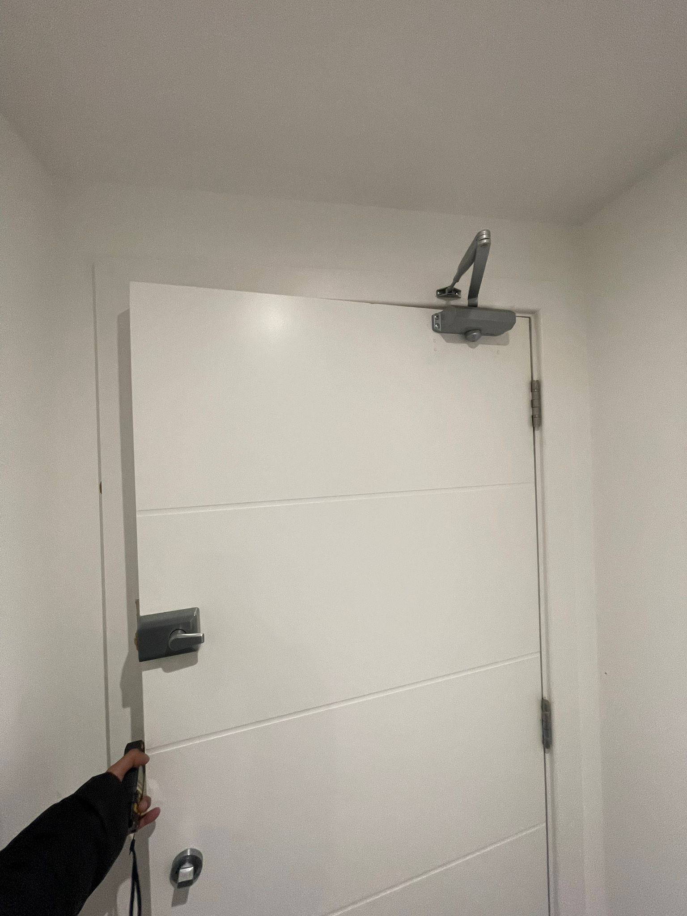

Photograph 1- Fire exit signs observed at the time of inspection. Emergency lighting provided and no obstructions to fire exit doors.
Photograph 2- self closing devices installed on doors. Building kept to an adequate standard. Fire extinguishers to be installed in the property and documents to be kept up to date for the local authority and emergency services.

1.01 Number of floors at ground level and above:
1.02 Number of floors entirely below ground level:
1.03 Floors on which car parking is provided:
1.04 Number of flats:
1.05 Approximate gross floor area:
1.06 Brief details of construction and approximate age of building:
1.07 Occupancy:
2.01 Approximate maximum number of employees at any one time:
2.02 Approximate maximum number of residents and visitors at any one time:
3.01 Sleeping occupants
3.02 Occupants in remote areas and lone workers:
3.03 Others:
3.04 Disabled occupants (if known):
4.01 Fires in the past:
4.02 Cost of past fire losses:
5.01 Detail here if required:
6.01 The following fire safety legislation applies to these premises:
6.02 The above legislation is enforced by:
6.03 Other legislation that makes significant requirements for fire precautions in these premises:
6.04 The other legislation referred to above is enforced by:
6.05 Is there an alterations notice in force?
6.06 Relevant information and deficiencies observed:
6.07 Other information if required:
7.01 Are reasonable measures taken to prevent fires of electrical origin?
7.02 a) Are fixed installations periodically inspected and tested?
7.02 b) Is portable appliance testing carried out?
8.01 Are reasonable measures taken to prevent fires as a result of smoking?
8.02 a) Is smoking prohibited in appropriate areas?
8.02 b) Are there suitable arrangements for those who wish to smoke?
8.02 c) Did the smoking policy appear to be observed at the time of inspection?
8.02 d) Are "No smoking" signs provided in the common areas?
9.01 Does basic security against arson by outsiders appear reasonable?
9.02 Is there an absence of unnecessary fire load in close proximity to the premises or available for ignition by outsiders?
10.01 Is there satisfactory control over the use of portable heaters?
10.02 Are fixed heating and ventilation installations subject to regular maintenance?
11.01 Are reasonable measures taken to prevent fires as a result of cooking?
12.01 Does the building have a lightning protection system?
13.01 Is the overall standard of housekeeping adequate?
13.02 a) Do combustible materials appear to be separated from ignition sources?
13.02 b) Is unnecessary accumulation or inappropriate storage of combustible materials or waste?
13.02 c) Are gas and electricity intake/meter cupboards adequately secured and kept clear of combustible materials?
14.01 Is there satisfactory control over works carried out in the building?
15.01 Are the general fire precautions adequate to address the hazards associated with dangerous substances used or stored within the premises?
16.01 Hazards:
17.01 Is the design and maintenance of the means of escape considered adequate?
17.02 a) Are there reasonable distances of travel:
17.02 a1) Where there is escape in a single direction?
17.02 a2) Where there are alternative means of escape?
17.02 b) Is there adequate provision of exits?
17.02 c) Do fire exits open in the direction of escape, where necessary?
17.02 d) Are the arrangements provided for securing exits satisfactory?
17.02 e) Is the fire-resisting construction (including any glazing) protecting escape routes and staircases of a suitable standard and maintained in sound condition?
17.02 f) Is the fire resistance of doors to staircases and the common areas considered adequate, and are the doors maintained in sound condition?
17.02 g) Are suitable self closing devices fitted to fire doors in the common areas?
17.02 h) Is the fire resistance of doors to meter cupboards/store rooms/plant rooms in common areas considered adequate, and are they adequately secured and/or fitted with suitable self-closing devices?
17.02 i) Is the fire resistance of flat entrance doors considered adequate, and are the doors maintained in sound condition?
17.02 j) Are suitable self closing devices fitted to flat entrance fire doors and, where fitted, maintained in good working order?
17.02 k) Are there adequate smoke control provisions to protect the common escape routes, where necessary?
17.02 l) Are all escape routes clear of obstructions?
17.02 m) Are all fire exits easily and immediately openable?
17.02 n) Are there reasonable arrangements for means of escape for disabled people?
18.01 a) Adequate levels of compartmentation between floors and between flats and the common escape routes?
18.01 b) Reasonable limitation of linings that may promote fire spread?
18.01 c) As far as can be reasonably be ascertained, reasonable fire separation within any roof space?
18.01 d) Adequately fire protected service risers and/or ducts in common areas, that will restrict the spread of fire and smoke?
18.02 As far as can be reasonably be ascertained, are fire dampers provided necessary to protect critical means of escape against passage of fire, smoke and products of combustion in the early stages of a fire?
19.01 Has a reasonable standard of emergency escape lighting system been provided?
20.01 Is there a reasonable standard of fire safety signs and notices?
21.01 Is a reasonable fire detection and fire alarm system provided in common areas, where necessary?
21.02 If there is a communal fire detection and fire alarm system, does it extend into the dwellings?
21.03 Where appropriate, has a fire alarm zone plan been provided?
21.04 Where appropriate, are there adequate arrangements for silencing and resetting an alarm condition?
22.01 Is there reasonable provision of manual fire extinguishing appliances?
22.02 Are all fire extinguishing appliances readily accessible?
23.01 a) Sprinkler system?
23.01 b) Misting system?
24.01 Type of other fixed system(s) installed:
24.02 Are there appropriately sited facilities for electrical isolation of any photovoltaic (PV) cells, with appropriate signage, to assist the fire and rescue service?
25.01 Safety assistance:
25.02 Fire safety at the premises is managed by:
25.03 Is there a suitable record of the fire safety arrangements?
25.04 Evacuation strategy:
25.05 Are procedures in the event of a fire appropriate and properly documented, where appropriate?
25.06 Are routine in-house inspections of fire precautions undertaken (e.g. in the course of health and safety inspections)?
26.01 Are all staff given adequate fire safety instruction and training on induction?
26.02 When the employees of another employer work in the premises, is appropriate information on the fire risks and fire safety measures provided?
27.01 Is there adequate maintenance of the premises?
27.02 Is weekly testing and periodic servicing of fire detection and alarm system undertaken?
27.03 Is monthly and annual testing routines for emergency lighting?
27.04 Is annual maintenance of fire extinguishing appliances undertaken?
27.05 Are six-monthly inspection and annual testing of rising mains undertaken?
27.06 Are weekly and monthly testing, six monthly inspection and annual testing of fire-fighting lift(s) provided for the use by firefighters or evacuation of disabled people (evacuation lifts)?
27.07 Other relevant inspections or tests?
28.01 a) Fire alarm tests (where relevant)?
28.01 b) Emergency escape lighting tests?
28.01 c) Maintenance and testing of other fire protection equipment?
29.09 Is the fire emergency plan available to the enforcing authority?
29.10 Are Personal Emergency Evacuation Plans (PEEPS) required and in place?
29.01 Is there a suitably located premises information box for the fire and rescue service?
29.02 Are there arrangements to keep the premises information box up to date?
30.01 Has information on fire procedures been disseminated to residents?
30.02 Is fire safety information disseminated to residents?

